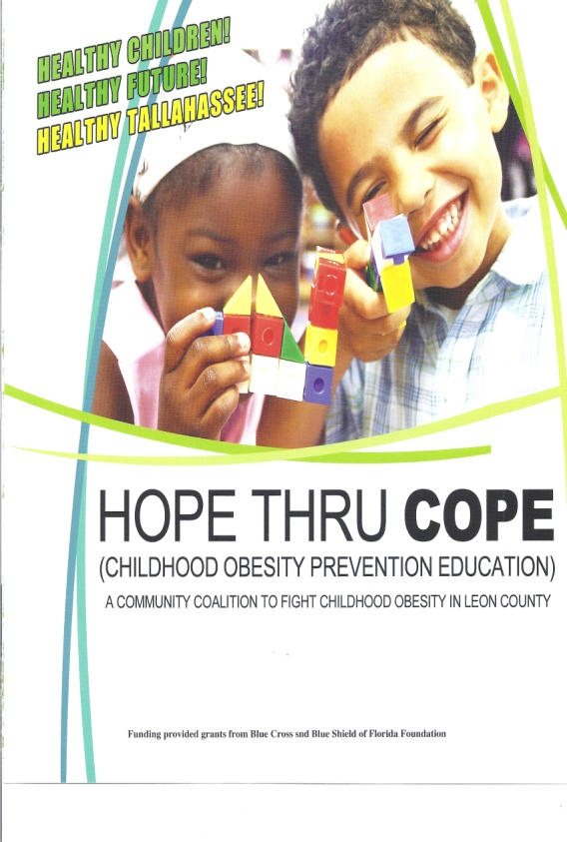

Application for
Youth health Leadership

Youth Health Leadership (YHL) is a signature program of the Childhood Obesity Prevention Education (COPE) Project, funded by the Florida Blue Foundation. The purpose of YHL is to engage youth in promoting and improving health and wellness through education and action in Tallahassee/Leon County. Those selected for YHL will participate in interactive educational sessions about improving health for themselves and others. Upon completion, YHL members become the youth arm of COPE, and will use the knowledge and skills learned to help improve health of their peers, families and the broader community. YHL is a unique opportunity for youth to increase knowledge about health and wellness, develop public speaking skills, and enhance leadership abilities while helping to improve the health of Tallahassee/Leon County.

We now have successfully completed three cohorts of YHL. In our inaugural cohort in 2013, eight youth completed all requirements, including establishing the YHL Facebook Page and developing a partnership with CHAMPIONS which provides fitness activities for elementary and middle school students. In 2014, twelve youth completed all requirements for YHL, developed a unique flyer with health messages to promote physical activity, partnered again with CHAMPIONS, and identified mental health as a key issue for COPE to explore. And in 2015, 11 youth completed all requirements, and developed and successfully implemented a community-based health campaign to build awareness about universal health including eating healthy, physical activity and stress management.
We are now recruiting YHL Cohort IV members who, once selected, will have the opportunity to complete requirements in 2016. A total of 15 new recruits will be selected through a competitive process. To be considered for YHL, the enclosed application should be completed and returned via email or fax to Gatavius Price no later than 5:00 pm on Friday, January 22, 2016. A review committee comprised of YHL alumni, parents, and advisors will interview qualified candidates and make selections. Criteria for selection for YHL include:
- Be high school age (generally between the ages of 14 and 18)
- Be an active member of a community organization (e.g. school, civic, fraternal, voluntary, faith-based)
- Have an interest in health
- Have an interest in being a youth health leader
- Commitment to attend YHL events in spring 2016

As a part of the process, youth being considered for YHL will be asked to participate in interviews during the week of February 1–4, 2016. A parent/guardian will be asked to attend the interviews as well. Selected youth and their parents will be notified in writing by the week of February 9, 2016. The YHL Induction Ceremony will then be held on Thursday, February 18, 2016. More details about the time and location of the event will be provided once youth are selected. The proposed YHL Cohort 2016 Calendar of activities is listed on the next page.

For more information about Tallahassee COPE, please go to www.tallycope.org. For more information about the YHL application process, please contact the following individuals at the FSU Center on Better Health and Life for Underserved Populations:
Penny Ralston, Ph.D., Professor, Dean Emeritus & Director (pralston@fsu.edu)
Iris Young-Clark, Ph.D., Associate Director (iyoungclark@fsu.edu)
Gatatvius Price, M.P.H., Assistant Project Coordinator (gaprice@fsu.edu)
(850) 645-8110 (Phone), (850) 645-8109 (Fax).

YHL Cohort IV 2016 Calendar
Recruitment Period November 2015

Application Rollout
(Emails out, Live on Website) December 9, 2015

Application Acceptance Period January 11-22

Review of Applications Week of January 25-29

Interviews February 1-4

Notification for Selections February 9

Induction Ceremony February 18

Parent/Youth Orientation February 23

Phase I: Sessions February 25, March 1, March 3

Phase II: Application Rotation March 7-18

Phase III: Health Campaign Planning March 22, March 24, March 29

Phase III: Implement Health Campaign Week of March 31- April 8 (possible sessions on March 31, April 5, and 7)

Recognition Ceremony April 12, 2016

Focus Groups June 7, 2016

Preliminary Application for
Youth health Leadership

Directions: Please complete the following application and submit by 5:00 pm on January 22, 2016. (No applications will be accepted after this date.) Applications should be submitted to Gatavius Price gaprice@fsu.edu or (850) 645-8109 fax. Please attach additional pages if you need more space.

Background
Name: _______________________________ Telephone Number: (___)___________________

Email Address: _________________________________________________________________

Local Address: _________________________________________________________________

School you currently attend: ______________________________________________________

What grade are you in? ________________ How old are you? ___________________________

Career Goals
What job/employment would you like to have in the future?
____________________________________________________________________________________________________________________________________________________________

Extracurricular Activities
What activities are you involved in with your organization? Include any leadership activities such as serving on committees or holding offices.
____________________________________________________________________________________________________________________________________________________________
List other extracurricular activities:
____________________________________________________________________________________________________________________________________________________________
List your interests and hobbies:
____________________________________________________________________________________________________________________________________________________________

Interest in YHL
Briefly describe your specific interest in becoming a part of YHL:
________________________________________________________________________________________________________________________________________________________________________________________________________________________________________________________________________________________________________________________

Youth health Leadership Parental
and Advisor permission Form

Parent/Guardian
I approve my child’s involvement in Youth Health Leadership. I understand that I will be invited and encouraged to attend all YHL educational sessions and other events.
Name:________________________________________________________________________

Relationship to applicant: ________________________________________________________
Address: ______________________________________________________________________
Telephone: (___)________________________________________________________________
E-mail: _______________________________________________________________________
Signature: ____________________________________________ Date: __________________

Please scan/email or fax completed application to Gatavius Price, gaprice@fsu.edu or (850) 645-8109 fax

For Organization Use Only
This section will be completed by an organization representative (e.g. teacher, advisor or adult leader) before the application is submitted.

Organization Representative
Name: ________________________________________________________________________
Organization: __________________________________________________________________
Address: ______________________________________________________________________
Telephone: (___)________________________________________________________________
E-mail: _______________________________________________________________________
Signature: ______________________________________ Date: ________________________
Do you support this applicant’s participation in Youth Health Leadership? Yes / No

